1. How do you use the "cp" command to copy a file named "file.txt" from the current directory to a directory named "backup"?

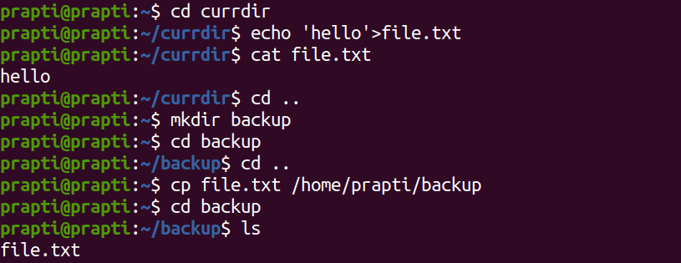

1. What is the difference between the "rm" and "rm -r" commands in Linux?
2. rm command rm removes a file from a directory.
3. rm -r command removes a directory from the system.
4. How do you use the "mv" command to rename a file named "oldname.txt" to "newname.txt"?

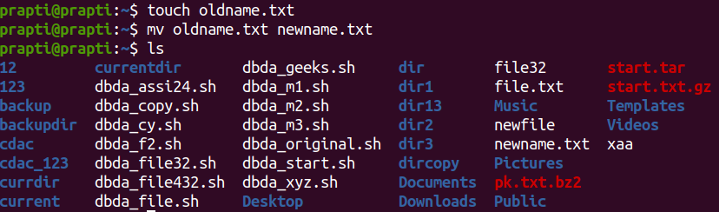

1. What does the "pwd" command do in Linux?

It prints the path of the current directory.

1. How do you create a new empty file named "newfile.txt" in the current directory using the command line?

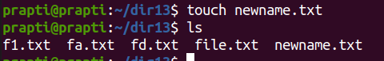

1. How do you rename a file named "oldname.txt" to "newname.txt" using the command line?

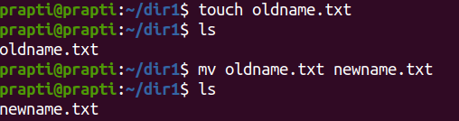

1. How do you remove a file named "file.txt" from the current directory using the command line?

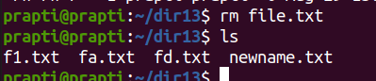

1. Use a command to show the current working directory



1. List the directory contents in the short and long format

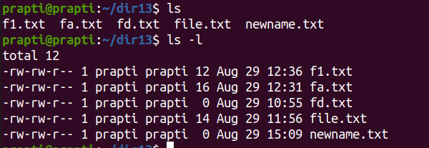

1. Explore attributes given in long format e.g. file type, file permissions, file size, file owner etc.

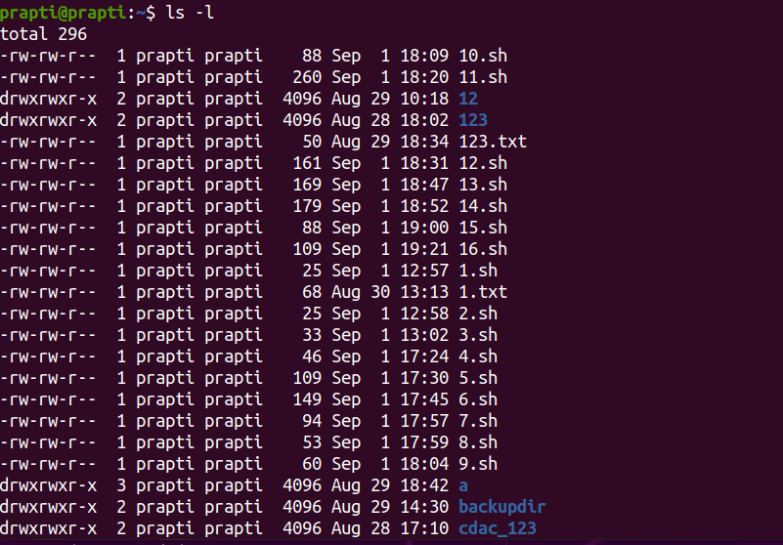

1. List all files along with hidden files in the current working directory.

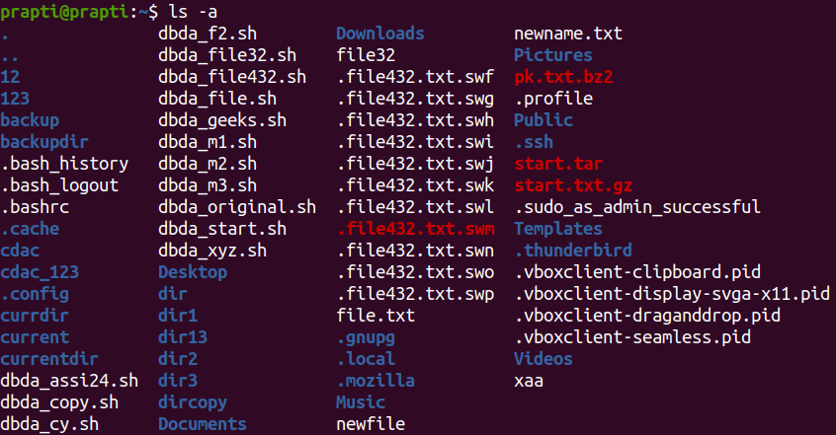

1. list only hidden files in the directory

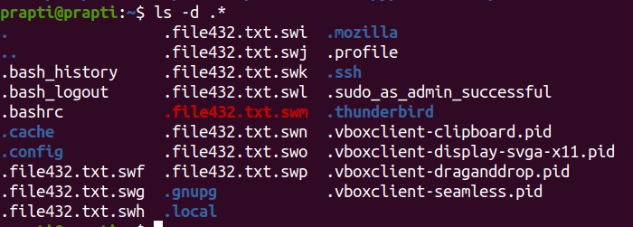

1. Make a directory and name it as **cdac-dir** ​and change the current working directory to the new directory.(Hint : use **mkdir,cd**​ commands). 3. Create following nested directories inside the current directory by invoking a single command for only one time.

Note : here root_dir is the current directory.

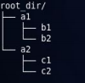 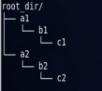

Directory structure 1 Directory structure 2

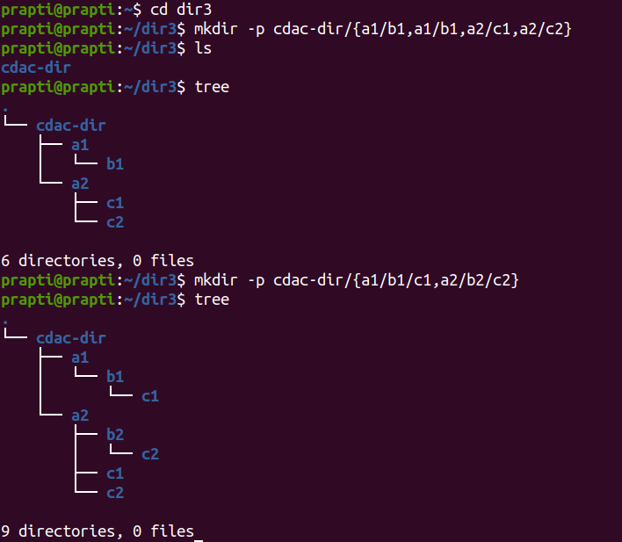

1. (Hint : explore the man page of **mkdir** ​). 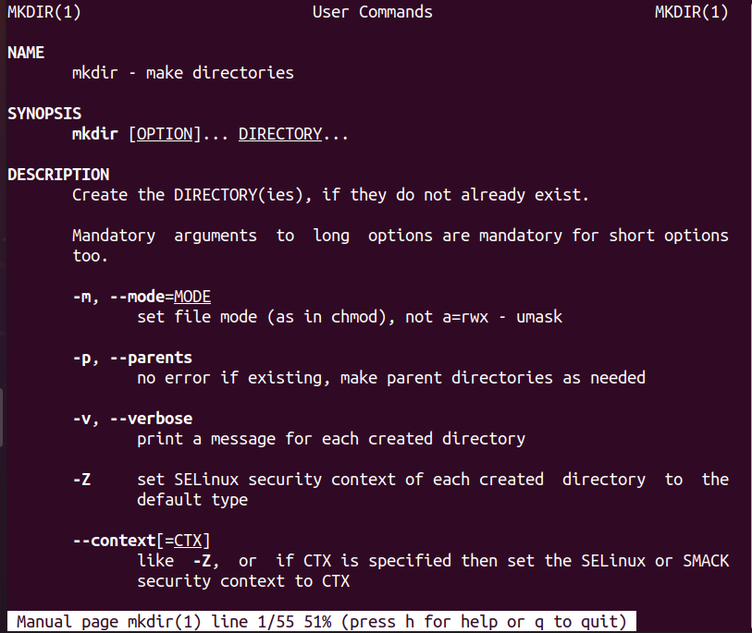
2. List the directories(folders), then remove the **cdac-dir** ​directory and list the folders again to show that it is no longer present.(Hint : use **rm, ls** ​command)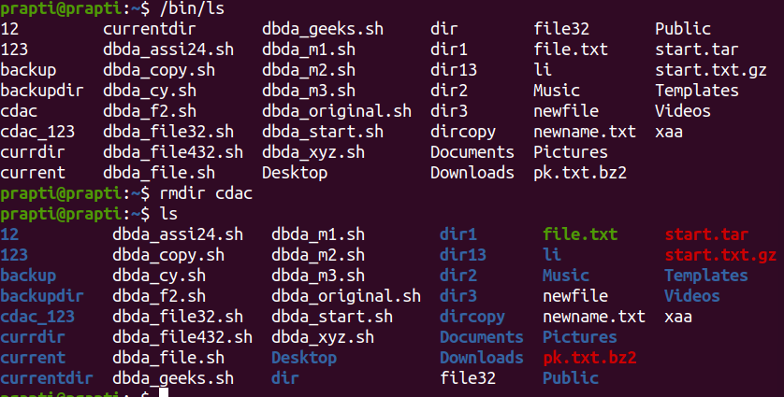
3. Question no.2
4. Display the **man-page**​ for **ls**​, but redirect the output into **temp.txt**​, then use the **cat,**​ **less**​, and **more**​ commands to display the new file. 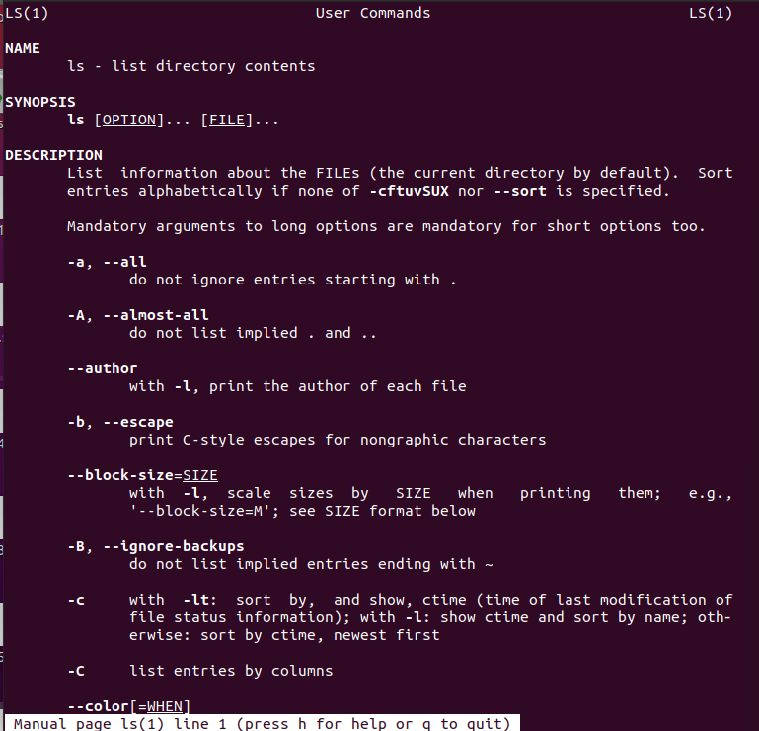
5. Display the initial 10 lines and final 5 lines of **temp.txt**​ with the obvious Linux commands.(Hint: use **head**​ and **tail**​ commands).

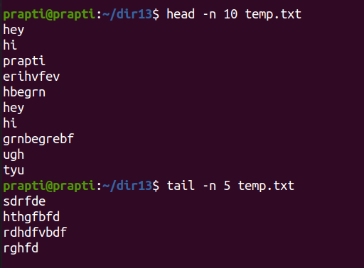

1. Copy **temp.txt**​ to another directory and rename it there.

(**Hint**​: use **cp**​ to copy and **mv**​ command to rename).

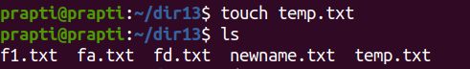

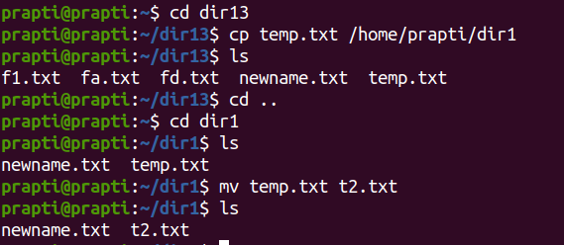

1. Display the number of lines, words and characters in file using Linux command (**Hint**​: use **wc** ​command).

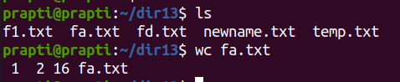

1. Use history command to display the last 10 commands used. (**Hint**​: use **history** ​command).

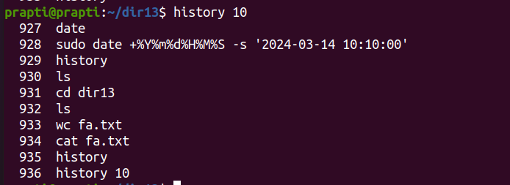

1. Create a tar archive file of any directory present in your home directory. (**Hint**​: use **tar** ​command)

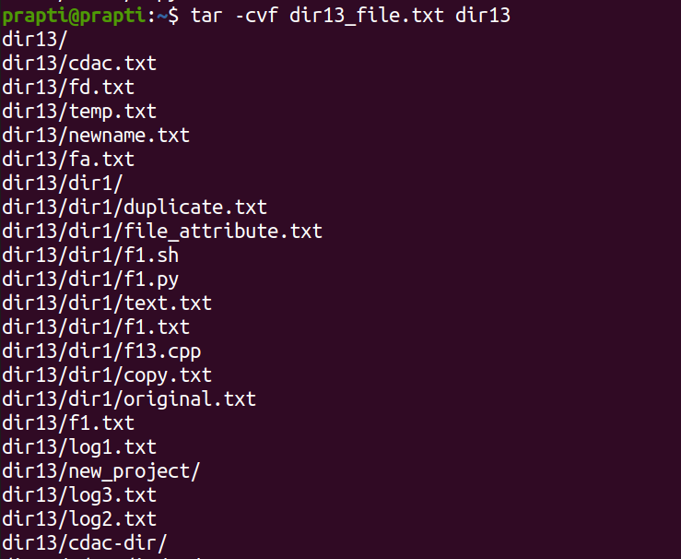

1. Create a zip file of another directory. (**Hint**​: use **zip** ​command) - list the contents of the zip file without extracting.

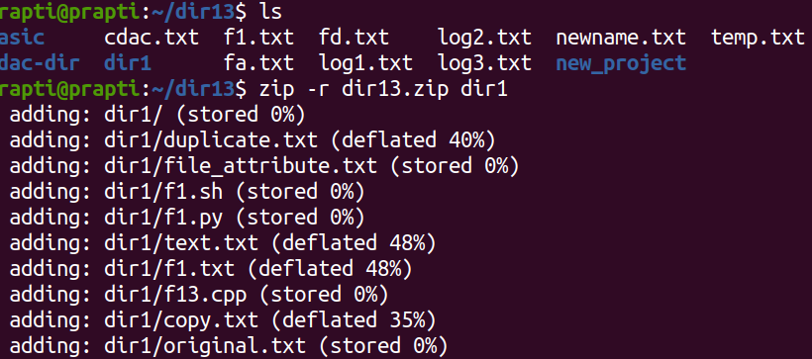

1. Give read, write & execute permissions to your file. (**Hint**​: use **chmod** command)

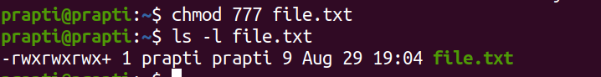

1. Change ownership of that file.(**Hint**​: use **chown**​ command)

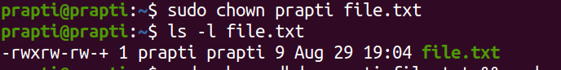

1. List processes running in shell, all running processes(**Hint**​: use man page of **ps** ​command) and show top processes in decreasing order of their resource utilization.(**Hint**​: use **top**​ command).

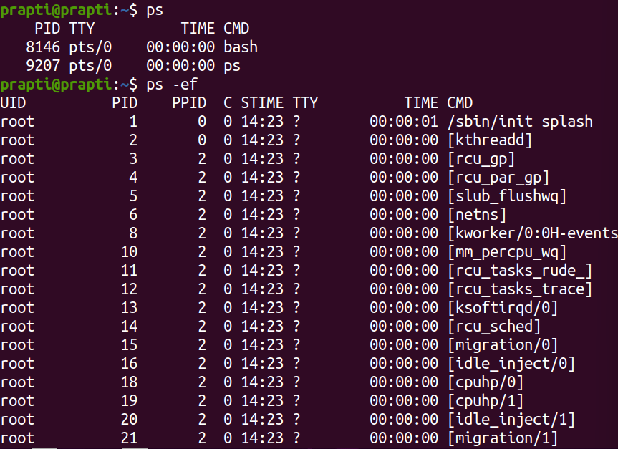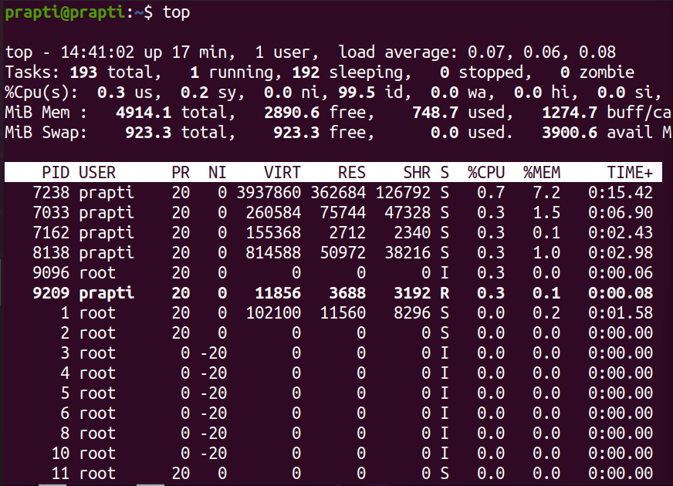

1. Display current time and calendar (**Hint**​: use **date, cal** ​commands) 2. Change the current date and time of the system to following 14th March 2024, 10:10 AM

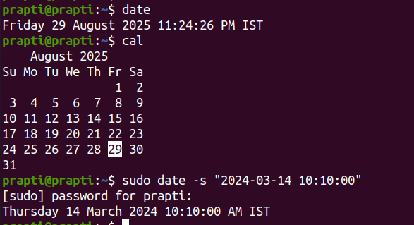

1. Explore following commands
2. who, whoami, whatis, whereis, (**Hint**​: use man pages).

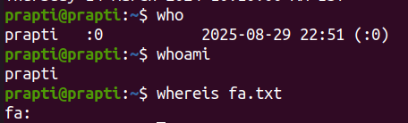

1. Create one directory named linux. cd to that directory and create one file named **testperms.txt.** ​Check the permissions of that file. Check the value of **umask**​. Change the value of umask and create one new file **newtestperms.txt** ​and check its permissions. Note down the difference.(Hint: use **umask, ls** command )

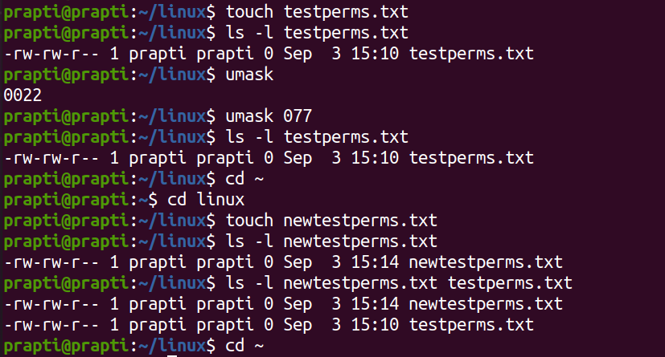

1. Create a file and name it as file1.txt and create a hardlink to this file. (Hint: use **ln**​ command).

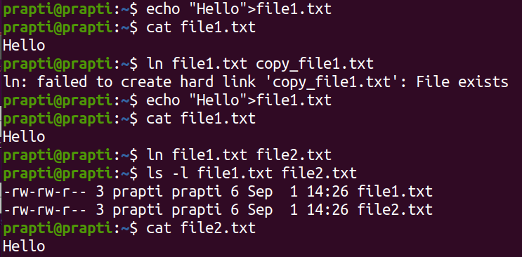

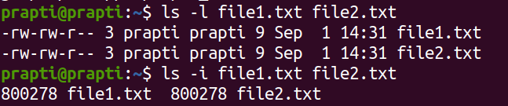

1. Create a file and name it as file2.txt and create a softlink to this file. (Hint: use **ln**​ command).

| Hard Link | Soft link |
| --- | --- |
| Hard line with being a link. | Soft link is a link which indicates path to  its parent file. |
| Since it is a file by itself, if parent file is  deleted, child file remains as it was  previously. | Since its a path, if parent file is deleted,  child doesn't point tp proper path and  becomes a zombie file. |
| Can be used for creating backup files. | Can be used as a shortcut. |
| Syntax is: In parentfile.ext childfile.ext | Syntax is: In -s parentfile.ext Q  childfile.ext (here, -s indicates soft link) |

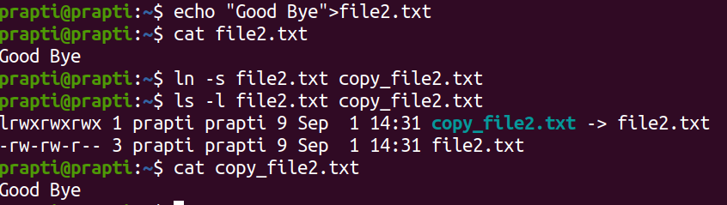

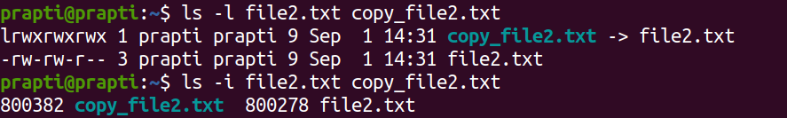

1. Use **ssh**​ to connect to your friend's shell by specifying **port number**​ in the **ssh** command. use **exit** ​command to come out of your friends shell.

(Hint: use **ssh**​ command)

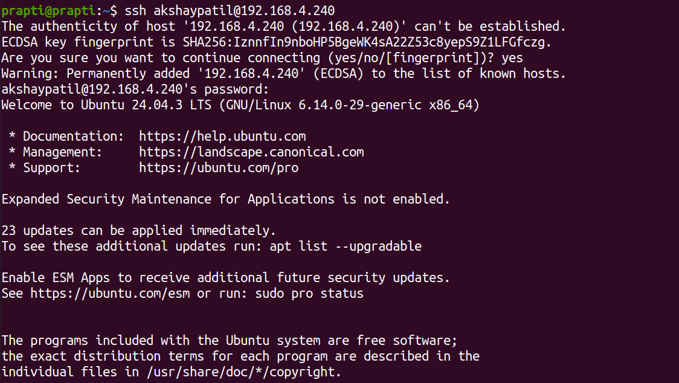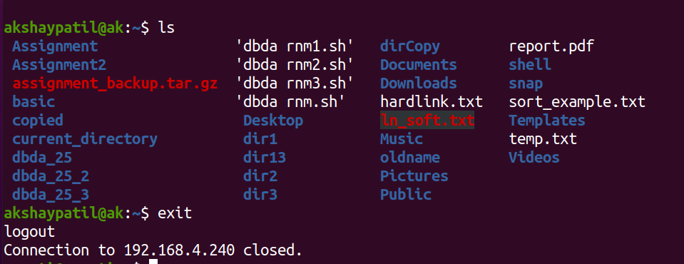

1. Use **scp**​ using your friend's credentials to copy a file​ into a directory **owned by your friend,** ​inside his home directory, specify port number in **scp**​ command.

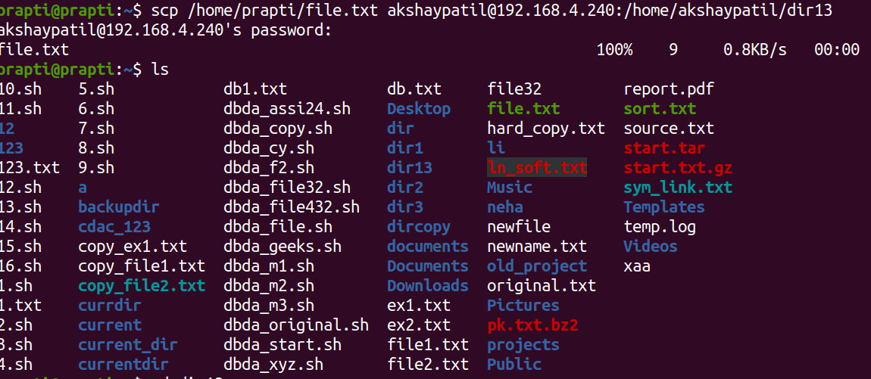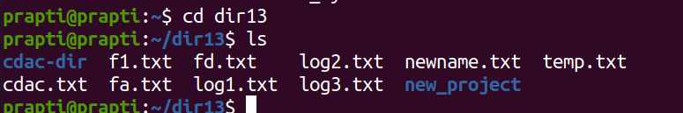

1. Use **scp**​ using your friend's credentials to copy **directory**​ into a directory **owned by you**​, inside your home directory, specify port number in **scp** command

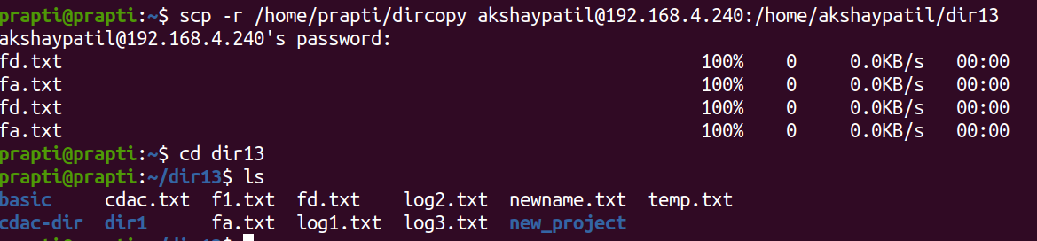

1. Use **scp**​ using your friend's credentials to copy **directory**​ into a directory **owned by you**​, inside your home directory, specify port number in **scp** command



1. Connect to any publicly available **ftp**​ server from the terminal and try to download, upload and delete files. If you get error in any process (connect, upload, download or delete), justify the reasons behind them.(Hint: use **ftp**​ command) Example:

Try to access **ftp.netbsd.org**

username : **anonymous**

password : **anonymous**

1. How do you remove a directory named "mydir" and all of its contents using the command line?

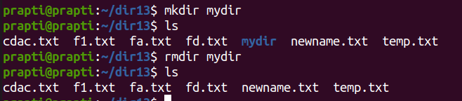

1. How do you use the "ls" command to list all files and directories in the current directory?

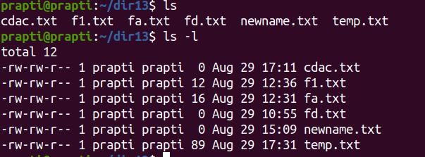

1. How do you create a new file named "myfile.txt" in the directory "/home/user/documents" using the command line?



1. How do you use the "grep" command to search for a specific word or phrase in multiple files at once?

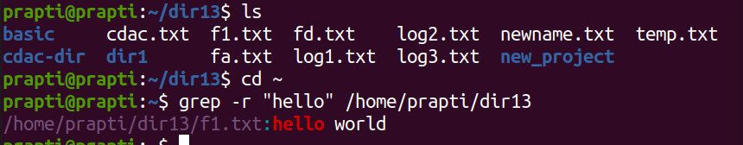

1. How do you create a new directory named "mydir" and set its permissions to read, write, and execute for the owner and read and execute for everyone else?

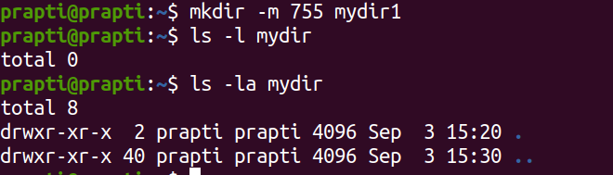

1. How do you use the "tar" command to create a compressed archive of all files in the current directory and its subdirectories?

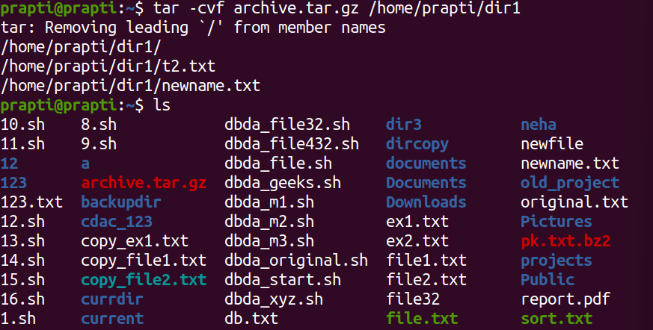

1. How do you use the "chmod" command to give read and write permissions to the owner and group for a file named "file.txt"?

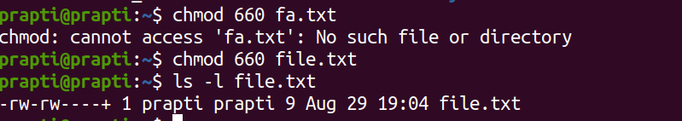

1. How do you find the size of a file named "file.txt" in bytes, kilobytes, and megabytes using the command line?



1. How do you use the "awk" command to extract a specific column from a comma-separated value (CSV) file and sort it in reverse order?

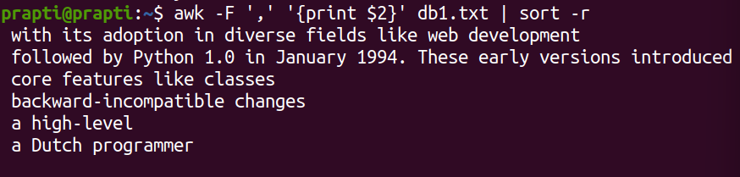

1. How do you use the "sed" command to replace all occurrences of a word or phrase in a file with a different word or phrase?

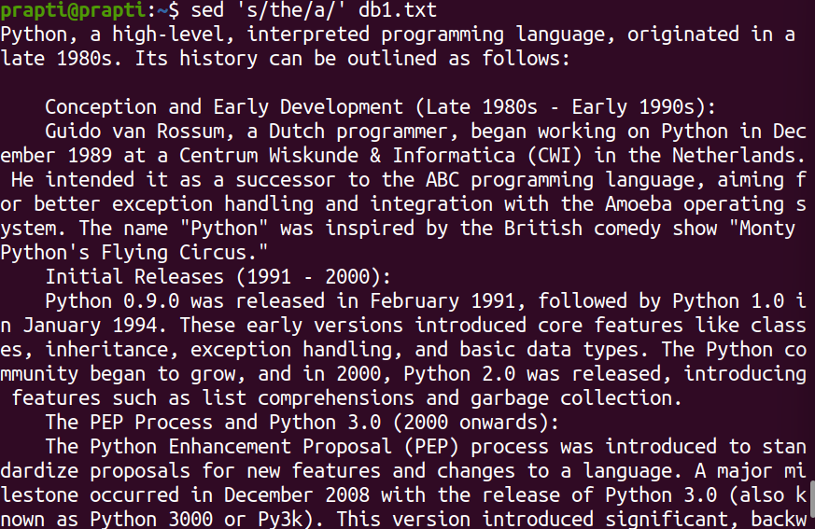

1. How do you use the "find" command to search for all files in a directory and its subdirectories that were modified within the last 24 hours?

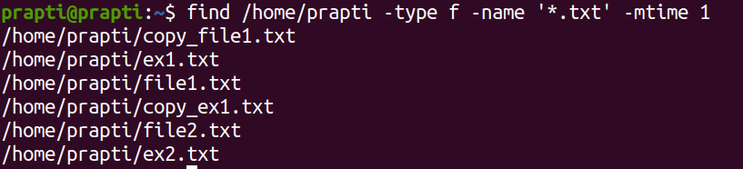

1. How do you use the "diff" command to compare two files and show only the lines that are different between them?

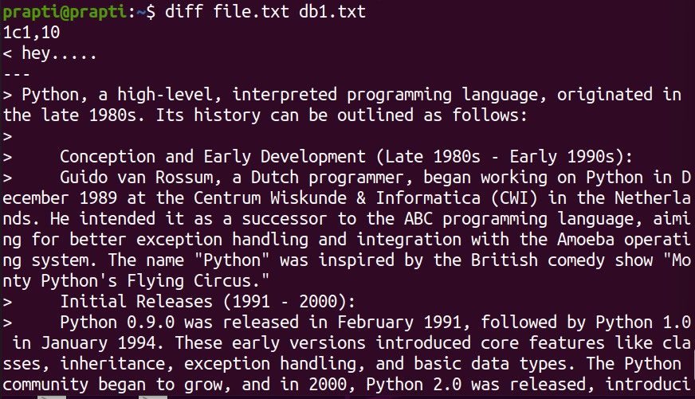

1. How do you use the "rsync" command to synchronize the contents of two directories, including all subdirectories and files, while preserving file permissions and ownerships?

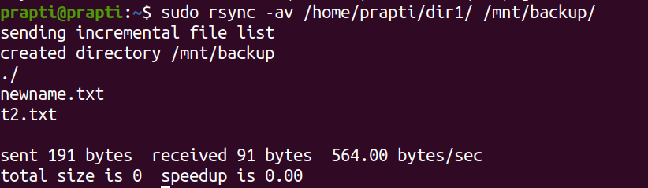

1. How do you use the "cut" command to extract a specific range of characters or bytes from a file?

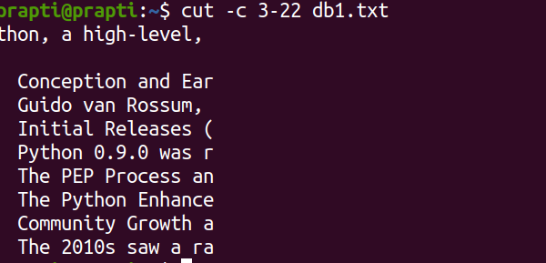

1. How do you use the "tar" command to extract a specific file or directory from a compressed archive without extracting the entire archive?

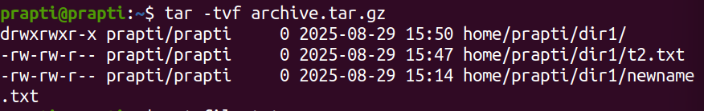

1. How do you use the "awk" command to count the number of occurrences of a specific word or phrase in a file?

